CPEG 207 Digital Systems HOMEWORK 7
Name: _______________________________________________
Show your work detail and clearly identify your answer.
- A) If the waveforms are applied to an active-LOW $\overline{S}-\overline{R}$ latch, draw the resulting Q output waveform in relation to the inputs. Assume that Q starts LOW.
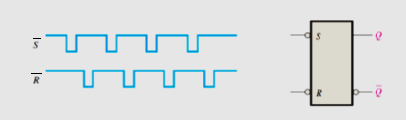
B) Solve Problem 1 A for the following waveforms.
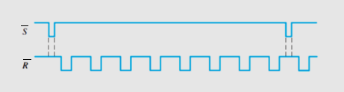
- A) For a gated S-R latch, determine the Q and $\overline{Q}$ outputs for the inputs. Show them
in proper relation to the enable input. Assume that Q starts LOW.
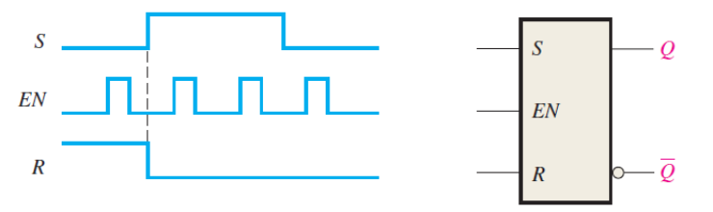
B) For a gated D latch, the waveforms shown are observed on its inputs. Draw
the timing diagram showing the output waveform at Q if the latch is initially RESET.
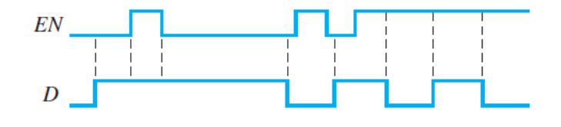
3. Two edge-triggered J-K flip-flops are shown; draw the Q output of each flip-flop relative to the clock. The flip-flops are initially RESET.
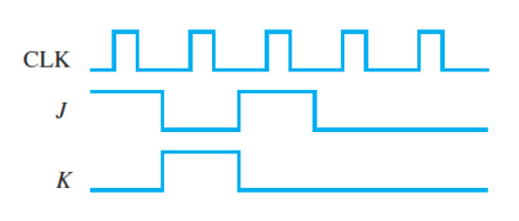 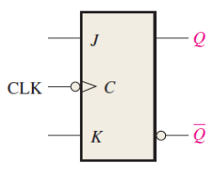 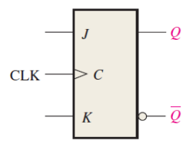
4. Determine the Q waveform relative to the clock if the signals shown are applied to the inputs of the J-K flip-flop. Assume that Q is initially LOW.
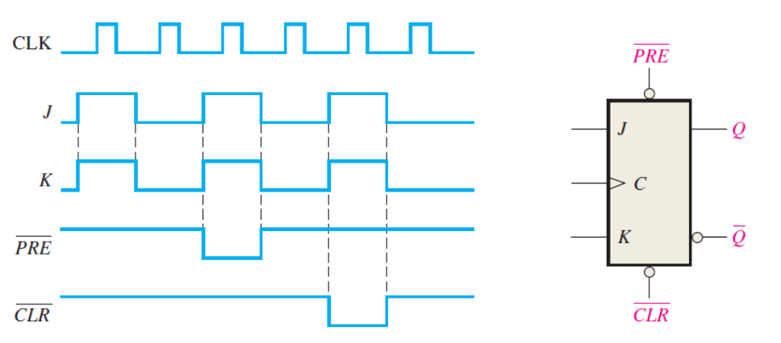

5. For the circuit shown, complete the timing diagram by showing the Q output (which is initially LOW). Assume $\overline{PRE}$ and $\overline{CLR}$ remain HIGH.

